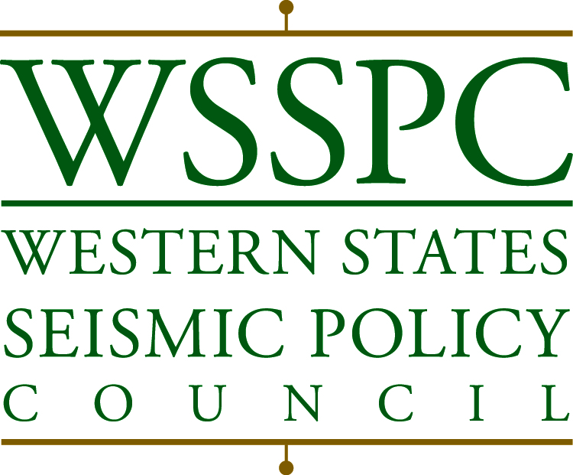

**WSSPC Awards in Excellence**

***2015 Nominations***

The Western States Seismic Policy Council (WSSPC) is pleased to announce it is accepting nominations for its 2015 Awards in Excellence. These annual awards honor exemplary programs, projects, and products that have significantly contributed to addressing earthquake risk reduction through new and creative approaches. Through these awards, WSSPC seeks to recognize the winners’ demonstrated achievements in earthquake mitigation, preparedness, and response, and facilitate the transfer of those successful experiences to others.

Winners will be honored during the 2015 WSSPC Annual Meeting. Recipients will be presented with a specially-designed plaque at the WSSPC Awards Luncheon, and featured in press releases, meeting materials, and on the WSSPC website.

**Eligibility**

During the award selection process, the following criteria are used to determine eligibility and rate the eligible nominations:

1. Is the program, project or product (NP) operated, administered or sponsored by a government entity, non-profit organization or public-private partnership?
2. Has the NP been operational for at least one year prior to the nomination date?
3. Does the NP address a significant earthquake risk reduction issue that is local, regional, state or national in scope?
4. Does the NP represent a new and creative approach to the earthquake risk reduction issue?
5. Has the NP effectively achieved its stated purpose, goals and objectives?
6. Could the NP and/or its results be easily transferred for use to another local, state or regional government or non-profit organization?

**Nominations**

Anyone from outside of the nominated program, project or product may submit a nomination, whether or not they are a member of WSSPC. To make a nomination, complete all of the information on the attached form and submit it with the supporting documents to *psutch@wsspc.org* by **Monday January 5, 2015**. For questions or additional information, please contact WSSPC at 916-444-6816 or go to *www.wsspc.org.*

**Winners**

Winners are chosen by the WSSPC Board of Directors. 2015 Award in Excellence selections – and their nominators – will be notified at the end of January 2015. Winners’ notification forms will be posted on the WSSPC website.

Attachment: 2015 WSSPC Awards in Excellence Nomination Form

**WSSPC Awards in Excellence**

***2015 Nomination Form***

**Nominated Program, Project or Product:**

|  |  |  |  |
| --- | --- | --- | --- |
| Program, Project or Product Name: **Great Nevada ShakeOut** | | | |
| Nominated Administering Organization**: Nevada Seismological Laboratory** | | | |
| Contact Name/Title**: Dr. Graham M. Kent** | | | |
| Street: **Nevada Seismological Laboratory, MS-0174, UNR** | | | |
| City:  **Reno** | | State: **NV** | Zip: **89557** |
| Telephone**: 775 527 1574** | Fax: | | |
| Email: **gkent@unr.edu** | | | |

**Nominating Individual or Group (must be nominated by someone outside the nominated organization)**

|  |  |  |  |
| --- | --- | --- | --- |
| Nominating Individual or Group: : **Chief Chris Smith** | | | |
| Agency Affiliation: **Nevada Division of Emergency Management** | | | |
| Street: **2478 Fairview Drive** | | | |
| City: **Carson City** | | State: **NV** | Zip: **89701** |
| Telephone: **775-687-0300** | Fax: | | |
| Email: [cbsmith@dps.state.nv.us](mailto:cbsmith@dps.state.nv.us) | | | |

**Award Category (check all that apply):**

|  |  |  |  |  |
| --- | --- | --- | --- | --- |
| **X** | Educational Outreach (choose all that apply from the following 3 sub-categories) | |  | Multi-jurisdictional Planning |
|  | **X** | Outreach to Business/Government |  | Mitigation Efforts |
|  | **X** | Outreach to General Public |  | Non-Profit Agency Efforts |
|  | **X** | Outreach to Schools |  | Research Projects |
|  | Innovations | |  | Response Plans/Materials |
|  | Legislation | |  | Use of New Technology |

**Evaluation of Program, Project or Product** (use as much space below each question as needed)

1. How long has the nominated program, project or product been operational?

(Note: to be considered for an award, it must have been operational at least one year prior to nomination.) Since: Month _**9_**___ Year _**2010**____

**The Great Nevada ShakeOut started in September of 2010. Nevada, along with Guam, were the first two entities to join the Great California ShakeOut and helped move ShakeOut into an international program.**

1. What is the major purpose of the program, project, or product? What problem or issue was it designed to address?

**The Great Nevada ShakeOut is an education and outreach program for the state of Nevada to increase the awareness of earthquakes in the 3rd most active state in the nation through its “Drop, Cover and Hold on” drill.**

1. Describe the specific activities and operations of the program, project, or product.

**Coordinate and run the ShakeOut drill on the 3rd Thursday, every October, with a focus on schools, government, hospitals and businesses. Our numbers have steadily climbed from 116K in our inaugural year to 570,000+ this past year in 2014.**

1. What new and creative approach or method does the program, project, or product use to address an issue or problem?

**The Nevada Seismological Laboratory used the “Big Shaker” simulation truck to attract more attention for upcoming ShakeOuts, but mostly shoe leather and some grit and determination to drive the numbers up! Reno and Las Vegas media has been very helpful in this regard.**

1. What was the start-up budget and source(s) of funding?

Budget: **$25K**_ Source: _**COS Funds @ UNR and Graham Kent’s startup**___________________

1. What are the annual operational costs and source(s) of funding?

Budget: $ **30-40K in 2014__** Source: _**NV DEM and Departmental Funds**_________________

1. How many employees (full-time equivalent) work(ed) with the program or project, or on the product? **_.25 FTE**____
2. Where did this program, project or product idea originate?

____ Originated within the nominated organization

__X__ Adapted from another source

* Original source: **Great California ShakeOut, 2nd group to do it**.
* How was it modified? **Adapted to NV. Even tsunami warnings for Lake Tahoe**.

1. Has the program been fully implemented? ___X__ Yes __X__ No

**Yes and No.** **We’ve made tremendous strides … but still rather underfunded. More one and one work at the school level and more outreach to businesses.**

1. If the program has not been fully implemented, what actions remain to be taken?

**See Above.**

1. Is there evidence that the program has been effective in achieving its stated purpose? Briefly summarize evaluations (pro and con) of how well the program has addressed the defined problem or issue.

**We’ve had great success with the ShakeOut program! It is highly visible and we have excellent media relationships to help drive home the larger issue of seismic risk in Nevada. We lack resources to attack business resiliency, which is our next focus—but we are light years ahead of our annual earthquake awareness week that didn’t have statewide impact, only spotty. ShakeOut is a great vehicle for this and we are proud to have been the 2nd state to help lead the charge!**

1. What limitations or obstacles were encountered? How were they overcome?

**Money. Still trying … otherwise, everyone has been extremely helpful and willing to help carry the message. It’s just a resource issue at this point, plain and simple.**

1. Additional information for the WSSPC Board to consider in evaluating the program, project or product. Supporting documentation, samples, or other items may be attached.

**Please see: http://www.shakeout.org/nevada/**

Submit the nomination form and all supporting documents to Executive Director Patricia Sutch at [***psutch@wsspc.org***](mailto:psutch@wsspc.org) ***.*** Documentation that cannot be sent electronically may be mailed to: WSSPC, 801 K Street, Suite 1236, Sacramento, CA 95814. If you have any questions, please feel free to contact us at 916-444-6816. Deadline is Monday January 5, 2015.