**For immediate release:**

February 6, 2019

**Contact:** Matthew Wall, Executive Director, Western States Seismic Policy Council916-444-6816

**WSSPC Board of Directors Names WSSPC Lifetime Achievement Award and Awards in Excellence Winners**

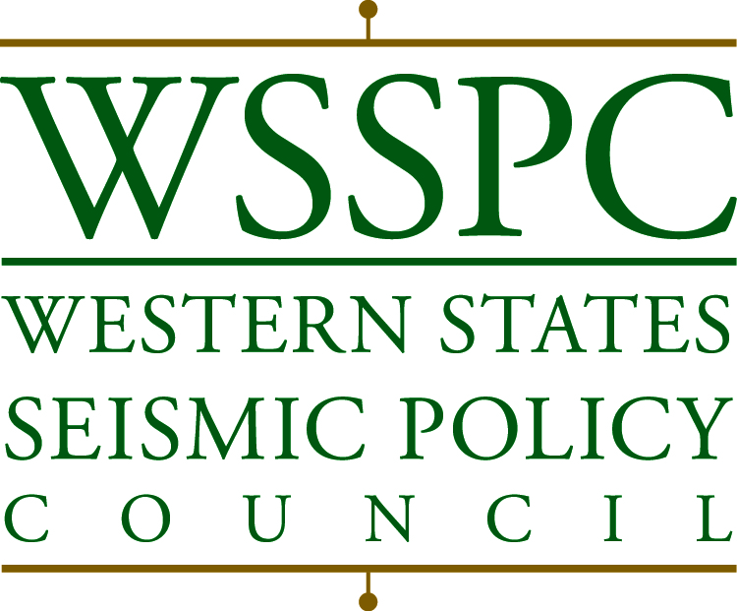

**Board of Directors**

2018-2019

Peter McDonough

*Chair*

Karen Berry

Caleb Cage

Mark ghilarduccI

Steve Masterman

John Metesh

Brad Richy

Matthew Wall

*Executive Director*

Lara Brodetsky

*Program Manager*

**Member States**

Alaska

American Samoa

Arizona

British Columbia

California

Colorado

Guam

Hawaii

Idaho

Montana

Nevada

New Mexico

Northern Marianas

Oregon

Utah

Washington

Wyoming

Yukon

801 K Street

Suite 1236

Sacramento,

California 95814

916-444-6816

fax 916-444-8077

wsspc@wsspc.org

http://www.wsspc.org

**Sacramento -** The Western States Seismic Policy Council (WSSPC) Board ofDirectors is pleased to announce its 2019 award winners! Each category acknowledged is listed below:

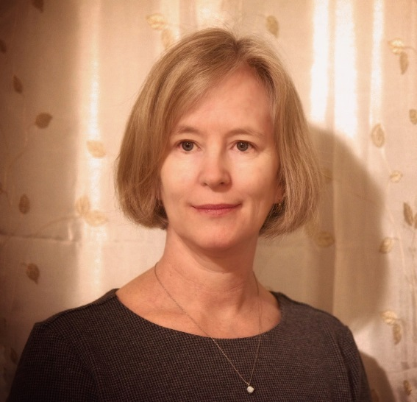*WSSPC Lifetime Achievement Award*: Presented to Laura Kelly for Dedication and Leadership in Earthquake Risk Reduction. Laura Kelly, Vice-Chair of the Alaska Seismic Hazards Safety Commission, has served for over eighteen years as a leader in earthquake engineering and risk reduction policy for Alaska’s Schools. Over the last 18 years, Laura has been a driving force behind the establishment of the Rapid Visual Screenings (RVS) for Alaska’s schools. She began tirelessly supporting this effort in 2001 when the United States Coast Guard Base Kodiak approved and funded her recommended Hazard Identification Projects for critical USCG facilities.

Ms. Kelly is a passionate, dedicated proponent of seismic mitigation and risk reduction. Equally commendable is the leadership role she has taken on the Alaska Seismic Hazards Safety Commission and her work concerning seismic safety for Alaska schools. The Alaska Seismic Hazard Safety Commission recommends goals and priorities for seismic risk mitigation to public and private sectors entities. The Commission also recommends risk mitigation policy to the governor and legislature to reduce the state's vulnerability to earthquakes.

In 2009, Laura Kelly received the USCG Engineer of the Year award which includes recognition for seismic vulnerability studies. Her 3-D computer mapping, and seismic vulnerability study work are two examples of how she improved the Coast Guard base by highlighting and prioritizing the mitigation of at-risk shore infrastructure.

She has provided input to testimony for legislators, advocating for seismic safety through training, effective building codes, seismic design review, on-site construction inspection and education.

In addition to serving the Alaska Seismic Hazards Safety Commission, her long-time career as a professional engineer, much of it in the area of safety, Laura Kelly has worked with the Alaska chapter of the Earthquake Engineering Research Institute (EERI) evaluating seismic risks for many of Alaska’s schools.

*Overall Award in Mitigation Efforts:* Presented to the Utah Division of Emergency Management for “Fix the Bricks.” Salt Lake City’s Fix the Bricks is a life safety program focused on mitigating the collapse risk of unreinforced masonry buildings (URMs). There are 31,892 residential URM’s in Salt Lake City which pose a significant threat to residents during an earthquake. URMs are expected to account for 90% of the 7,400 – 9,000 serious injuries and 2,000 – 2,500 deaths when an earthquake occurs along the Wasatch Fault. Fix the Bricks plans to reduce the number of deaths, injured, and trapped after the earthquake by facilitating seismic improvements for its residents.

*Educational Outreach Efforts:* Presented to the Washington Emergency Management Division for Be Tsunami Siren & Evacuation Map Aware. Be Tsunami Siren & Evacuation Map Aware designed an advertising campaign targeting their coastal populations, encouraging them to walk their tsunami evacuation routes and understand the role of tsunami sirens. The themes are: “Are you in the zone?” and “Don’t wait for the siren to go off.” They did this after seeing uncertainty from the population of what to do in the face of a potential tsunami originating off the coast of Alaska in January 2018. Additionally, local emergency managers requested assistance in spreading hazard awareness messages during a tsunami siren test in October.

The Awards will be presented at the 2019 Western States Seismic Policy Council Annual Meeting held at The Marriott University Park in Salt Lake City, Utah, at an Awards Lunch on April 26, 2019. Summaries of the 2019 winning programs and projects are posted on the Western States Seismic Policy Council’s website at *www.wsspc.org*.

The WSSPC *Lifetime Achievement Award* and *Awards in Excellence* programs was started in 1996 to recognize achievement in different areas of earthquake mitigation, preparedness and response.